Bryanna Hardy

05 February 2020

ARM Programming Detail Report

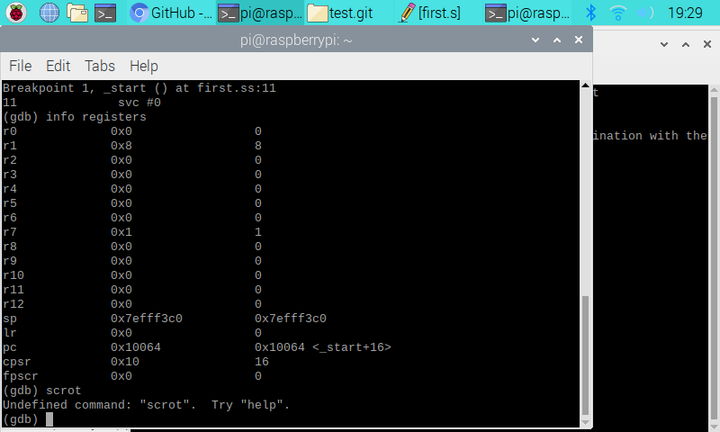

This is the tutorial register information. Eight is stored into register 1.

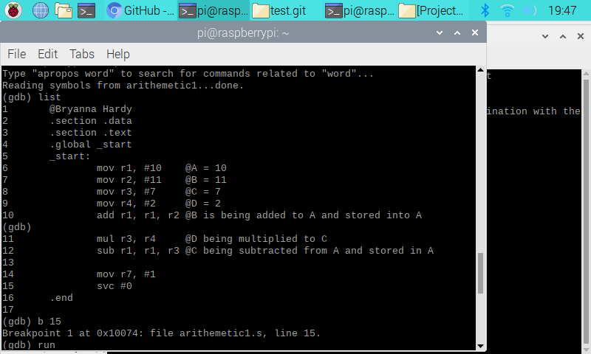

This is the ARM Assembly program I had to create. It is basically stating that 10 is being stored in register 1. Eleven is being stored into register 2. Seven is being stored into register 3. Two is being stored into register 4. Now that I have stored my integers into my registers, I am adding register 2 to register 1 and letting that sum be stored into register 1. Next, I multiplied register 4 to register 3. Lastly, I am subtracting register 3 from register 1, and letting that difference be stored into register 1. Down below, there is a screenshot of the register information. It should show that register 1 (r1) stores 7, which should be our answer from the equation, (A+B) – (C\*D).

